KS1 R.E. Long Term Plan 2023-2024
Term | Year 1 | Year 2
Aut | 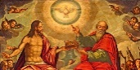 Autumn A: Why do Christians call God ‘Creator’?  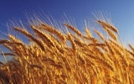  Time to Pause: Harvest  Autumn B: What is the ‘Nativity’ and why is it important to Christians?  Time to Pause – What is Mawlid? Who is Muhammad? *  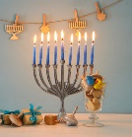  Time to Pause – Why do Jewish families celebrate Hanukkah? 7/12/23-15/12/23  Advent prayers (displayed in the church)  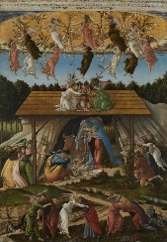 Time to Pause: Christmas | Autumn A: What is God like for Christians?  Time to Pause: Harvest  Autumn B: Why is giving important to Christians?  Time to Pause – Why do Jewish families celebrate Hanukkah? 7/12/23 - 15/12/23  Advent prayers (displayed in the church)  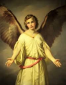  Time to Pause: Christmas
Spr | Spring A: Judaism 1  Why do Jewish families celebrate the gift of Shabbat?  Visit: Synagogue visit Week 3  Spring B: Judaism 2  What is the Torah and why is it important to Jewish families?  Time to Pause: Easter  Visit: Cathedral - Easter | Spring A: Islam 1  What is important for Muslim families?  Visit: Redhill Mosque  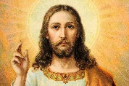Spring B: Why do Christians call Jesus ‘Saviour’?  Time to Pause: Easter
Sum | 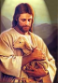  Summer A: What do Christians learn from the stories of Jesus?  Time to Pause – Pentecost (2024 Whitsun)  Summer B:  Thematic Unit: What makes a good leader? | Summer A: Islam 2  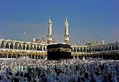  Who is Allah and how do Muslims worship him?  Time to Pause – Pentecost (2024 Whitsun)  Summer B:  Thematic Unit: Why should we look after the world?
Key: Christianity Judaism Islam
Time to Pause
Year 1 and 2 only What is Mawlid? Who is Muhammad? * - Mawlid – Muslim people view this celebration as a sign of respect and adoration of Muhammad whom they believe to be God’s messenger. (Yearly)
Harvest (Yearly)
Why do Jewish families celebrate Hanukkah? (Yearly)
Easter Pause Day materials:
- EYFS Mary’s story
- KS1 witnesses, Easter Journeys
Pentecost Pause Day (Alternate Years)

EYFS R.E. Long Term Plan 2023-2024
Term | Unit
Autumn | Why do we have celebrations?  Celebrations: Judaism- Sukkot 29th Sept -6th Oct 2023  Celebrations: Hindu – Diwali Sun 12th Nov 2023  Pause Day: Harvest: It’s good to share  Who am I and where do I belong?
Spring | Celebrations: Chinese New Year: Saturday 10th Feb 2024  What can we learn from stories?  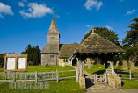  What makes a place special?  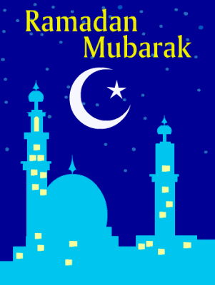  Celebrations: Hindu Holi: Monday 25th March 2025  Celebrations: Islam Ramadan(30 days) March 10th – April 9th Eid – 9th and 10th Apr  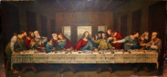  Pause Day: Easter: Meals with Jesus or New life all around
Summer | What makes our world wonderful?  Pause Day (2024) – Pentecost Whitsun – Sunday 19th May  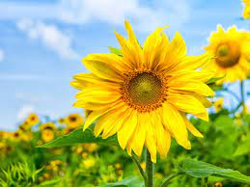 What makes something special?

